City Semester Math 13-14 Ms. Nelson

PROBLEM SET 1-1: Tables and Graphs

"Statistical thinking will one day be as necessary for efficient citizenship as the ability to read and write.”
-H.G. Wells (Don’t know who that is? Look it up!)
- Visit New York City Independent Budget Office’s site: New York By The Numbers: http://ibo.nyc.ny.us/cgi-park2/
Find one graph/dataset from NYC BTN particularly interesting to you to present to the group – use the archive links on the top right as well – endeavor to pick one you think no one else will.

The following table shows data on arrests made in NYC for 1 year according to NYPD figures:
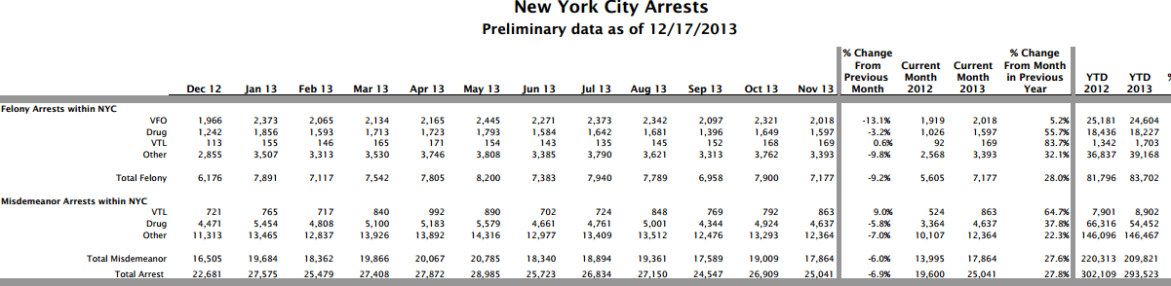
Source: http://www.criminaljustice.ny.gov/crimnet/ojsa/greenbook.pdf 1/20/14

- How many total arrests were made in NYC from Dec 2012 to Nov 2013?
- What percentage of the total crimes were felonies?
- What percentage of the July misdemeanor arrests were drug related?
- Write a complete sentence that fully describes where the number 5.2% (found in the VFO row) came from and what it means.
- Do you see any patterns in arrests over the course of a calendar year? If so, describe.
- How was 2013 compared to 2012? – write a brief summary with supporting evidence you could give to a news agency. Compare more than just total arrests.
The following table shows the number of tons of municipal waste disposed PER DAY in each of the five boroughs for the fiscal years of 2007 and 2010:
 | 2007 | 2010
Staten Island | 795 | 739
Queens | 3019 | 2891
Bronx | 2030 | 2044
Brooklyn | 3484 | 3305
Manhattan | 2226 | 2011

- Approximately how many tons of waste were disposed of in all of 2010?
- What was the approximate annual rate of change (in tons per year) for each borough from 2007 to 2010?
- Research the population of each borough in 2010. Which borough produced the
most trash per resident per day? The least?
Source: Dept of Sanitation annual reports
http://openlab.citytech.cuny.edu/wastemodel/2013/05/02/
historical-data-of-municipal-solid-waste-generation-in-new-york-city/ 1/22/14

- Design a single visual that encompasses this data.
- Where does it go???
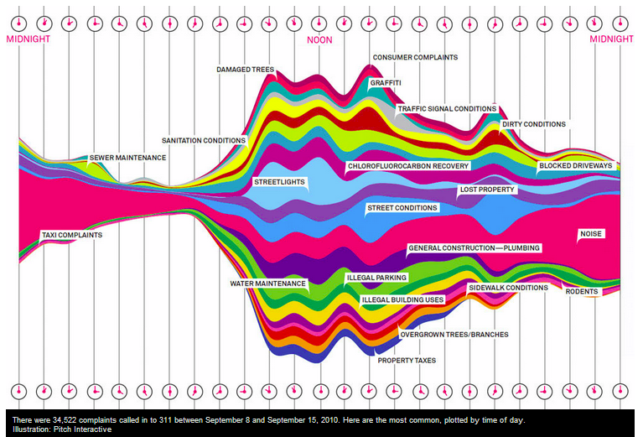
This graphic shows information about the type of complaints received by 311 each day,
tracked by hour, based on a survey of a few days in 2010 by Wired Magazine.

- Look at it. Learn something interesting. ☺
Source: http://www.wired.com/magazine/2010/11/ff_311_new_york/

